Chapter 2 – Building a Development Process Workflow
To become a successful planning and implementing CI/CD with Microsoft Fabric, you must understand the fundamental principles of CI/CD. For example, you should be familiar working with a GIT-based source control system such as Azure DevOps or GitHub. You should also be familiar with branching strategies and a development process which uses feature branches, pull requests and an integration branch.
Beyond knowing traditional CI/CD concepts, you need to learn what makes CI/CD with Fabric different. One aspect that is different for experienced CI/CD developers coming to Fabric is the need to pair GIT branches with Fabric workspaces. The Fabric development process allows developers and less-technical users to update workspace items directly using a browser. This is very different from the traditional CI/CD development process where a developer clones a remote repository and makes updates directly to the code in one of the repositories branches.
Planning and implementing a CI/CD strategy with Fabric involves deploying and updating the definitions for items that exist within the context of a Fabric workspace. When deploying a Data analytics solution or AI solution in Fabric, you’re required to create a separate workspace for long-lived GIT branches such as dev, test and prod. You will also need to create a new workspace or reuse an existing Fabric workspace every time you create and begin to work with a new feature branch.
This section will begin with a primer to review of the concepts and terminology of traditional CI/CD. After that, the article explains how Microsoft Fabric provides GIT integration and CI/CD features to provide support managing the lifecycle of workspaces items such as lakehouses, notebooks, pipelines, semantic models and reports. Along the way you also learn how to manage CI/CD for infrastructure-level items such as workspaces, workspace settings and connections.

Creating a Fabric CI/CD Project
Now that you understand some of the fundamentals of the Fabric support for CI/CD, it's time to discuss starting a new project. Let's begin with a discussion that differentiates between a Fabric solution and a Fabric CI/CD project.
You can think of a Fabric solution as a set of workspace items that have been designed to work together. The idea is that these workspace items as a whole provide value in terms of data analytics of AI. In a simple scenario, all the workspace items in a Fabric solution can be deployed to a single workspace.
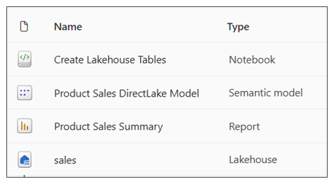
What should you do when you want to deploy a Fabric solution using Fabric CI/CD support? That's when you need to create a Fabric CI/CD project in which the solution's workspace items are replaced across multiple workspaces as shown in the following diagram.
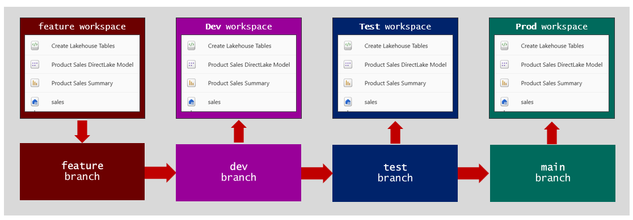
A Fabric solution can also be deployed across two or more workspaces. To keep things simple, this article will start by examining a Fabric solution deployed to a single workspace. This article will revisit the topic of creating a Fabric CI/CD project based on a Fabric solution that is spread across multiple workspaces later in the chapter.

Choosing a Branching Strategy
Another Important distinction when designing a branching strategy is to determine which branches are long-lived and which one are only temporary. The integration branch is a long-lived branch as it will be created at the start and will have a lifetime as long as the CI/CD project itself. Branches up the hierarchy to main are also long-lived branches. In the two diagrams above, the main branch, test branch and dev branch are examples of long-lived branches.
Feature branches are typically short-lived branches. For example, a feature branch is created when it's time to creating or update a workspace item such as a notebook or a report.
You can implement CI/CD using a cloud-based service that supports GIT-based repositories such as Azure DevOps, GitHub or GitHub Enterprise. Once you have created a new repository for CI/CD purposes, you must then decide the best way to create and managed the branches. The software industry has adopted several popular strategies for managing GIT branches and workflows such as Gitflow, GitHub Flow and Trunk Based Development.
Selecting the best branching strategy for a particular project depends on several factors including the size of the team, the complexity of the project and the frequency with which changes must be promoted into production.
Additional Resource
- Creating project and repositories in Azure DevOps
- Adopting a GIT branching strategy in Azure DevOps
- Creating repositories in GitHub
- Adopting a GIT branching strategy in GitHub

Implementing Infrastructure CI/CD
Infrastructure ID involves creating items that need to be created and configured a single time in the initial deployment. Examples of infrastructure components include servers, containers, databases and connections, These infrastructure components are created during the initial deployment.
After the infrastructure components has been created, the lifecycle process can begin. Application CI/CD now starts and continues as the infrastructure CI/CD has been completed to be
Add section about the difference between Workspace Item CI/CD and Data CI/CD. Data CI/CD is about building processs and running jobs to ingest and transform data and to continually keep data up to date. CI/CD workflows should not contain logic for data processing. Instead, you should abstract out ETL logic by building it into workspace items such as notebooks, pipelines, copy jobs and dataflows.

At the start of a Fabric CI/CD project, there are one-time provisioning operations that just need to be completed once.

Infrastructure CI/CD is different from CI/CD with workspace items. Infrastructure CI/CD involves provisioning platform level resources. For example, infrastructure CI/CD in general application development might involve providing resources such as networks, load balancers or databases. In Fabric, infrastructure CI/CD involves provisioning platform-level items such as workspaces, capacities and connections.
Fabric provides a set of workspace items that can be created within the scope of workspace. Fabric also provides platform items which are not created at workspace scope. Instead, platform items are created within the scope of the current Entra Id tenant. Examples of these platform items include Workspace, Capacity and Connection.
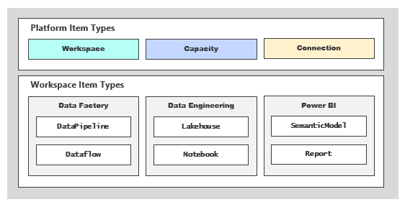
Ssss
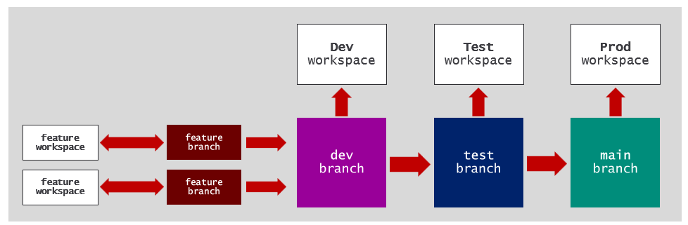
When deploying a Fabric CI/CD project with an end-to-end workflows, you must create
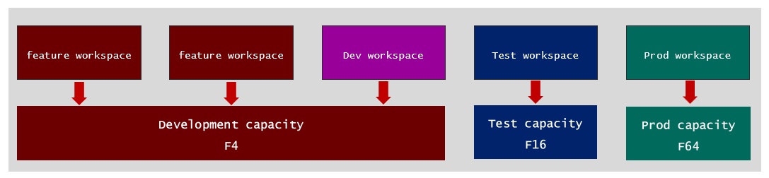

Designing End-to-end Parameterization using Variable Libraries
nn

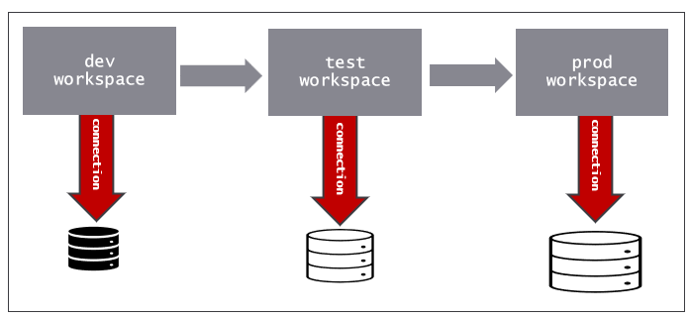

Setting up the GIT repository

Setting up the integration branch

Managing feature branches and feature workspaces
When implementing CI/CD for a Fabric solution, you can use a GIT service such as Azure DevOps or GitHub just like when implementing traditional CI/CD for general application deployment. However,
Microsoft Fabric is different because it focuses on data analytics solutions built using Fabric workspaces and workspace items. With Fabric CI-CD, you need a create a separate workspace for each stage such as dev, test, prod and you also need to create a workspace for each new feature. Traditional CI/CD optimizes for deploying code and services, while Fabric CI/CD is designed around deploying workspace items such as lakehouses, notebooks, semantic models and reports. The pipeline is less about building and testing applications and more about versioning and promoting workspace item definitions.
How do we get things set up at first. Image the dv workspace already has a set of workspace items that represent a Fabric solution. You can
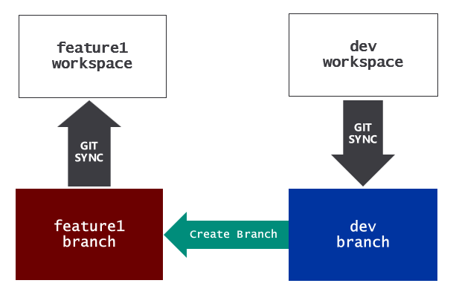
The GIT sync process recreates all the workspace items. However, it doesn’t always do all that is required to setup the feature workspace. You might have to run fix up code to create connections and bind them to semantic models and other dependencies .
Once the feature workspace is set up, you can take make changes by editing and modifying workspace items in the browser. Update code in notebook. Edit the layout of a report. When you’re done, you can sync changes from the workspace back to the feature branch. After that, you can push changes from the workspace back to the feature branch. After that, you can create a pull request to merge changes back to the dev branch.
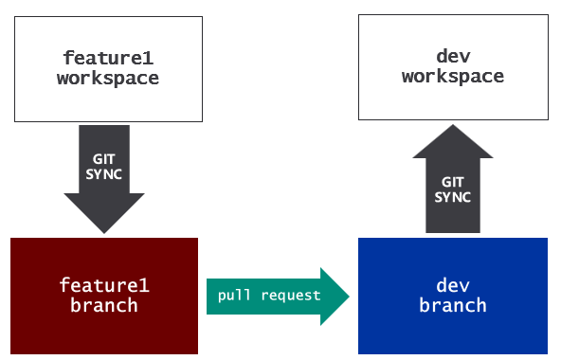
As you’ve seen, you can keep things simple by modifying workspace items using the browser in the feature workspace. However, for developers that prefer working directly with code, there is another option.
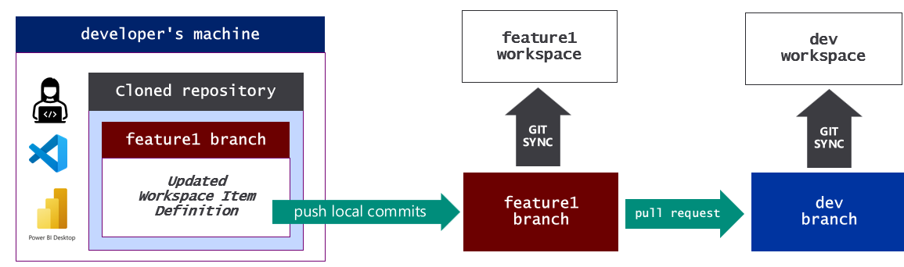
In effect, the developer is making changes directly to the files in the feature branch. However, the developer likely wants to test those changes in the feature workspace. Therefore, it is necessary to pull the changes from the dev branch into the dev workspace.

Let’s walk through a basic example of implementing CI/CD using the GitFlow branching strategy. The GitFlow strategy will always involve a main branch, a dev branch and feature branches. It also might involve release branches and hotfix branches.
The main branch holds the production-ready code that can be deployed to the production environment. The dev branch is the place where all changes will be merged. Changes that have been merged to dev will go through a validation and approval process. Once the changes that have been merged into dev have been approved, theses changes can be promote to main.
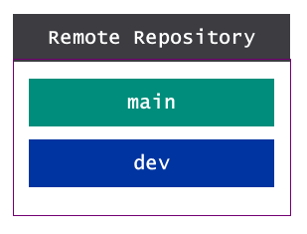
Let’s walk through the steps involved when a developer needs to add or modify application code. The process is started by creating a new feature branch which is initially a copy of the dev branch. A developer can clone the feature branch to create a copy of the files on the developer’s local machine. This allows the developer to begin writing and testing changes.
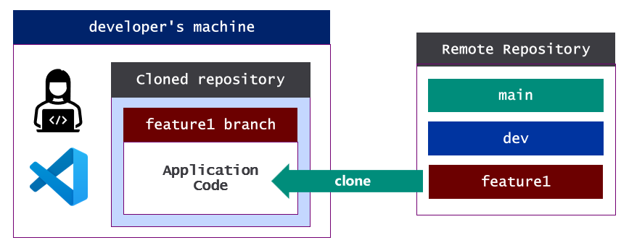
Developer commits changes and pushes then back to remote feature branch.
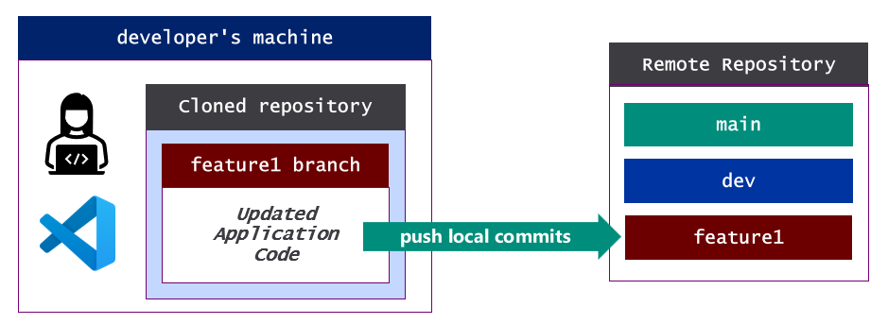
At this point the feature branch contains changes that need to be merged into the dev branch. That brings us to our next topic which is pull requests.
Additional Resources
- Learn about working with branches in Azure Dev Ops
- Learn about working with branches in GitHub

Building a development process workflow
Who are the developers? In traditional CI/CD, these are the people making updates to application code written in programming languages such as Java, C#, JavaScript and TypeScript.
Who are the people we refer to as 'developers' in a Fabric CI/CD project? It could be a professional developer, but it could also be people with expertise with some type of workspace items. These people might not have any experience working woth code directly.
It some cases the people updating workspace items will not be "developers". Report designer just works with UI. Pipeline author

Merging changes using pull requests
In GIT-based system, developers use pull requests to merge their changes from one branch to another. When you create a pull request, you are creating a proposal to merge a set of changes from one branch into another. In most cases, the will involve an approval process that requires interactive participation on the point of humans. This adds in quality control.
Once a pull request is approved, the changes for the pull request are automatically merged into the target branch. Pull requests are used to merge changes from feature branches to the dev branch. Once changes in the dev branch are ready for production, a pull request is created to promote those changes from the dev branch to the main branch.
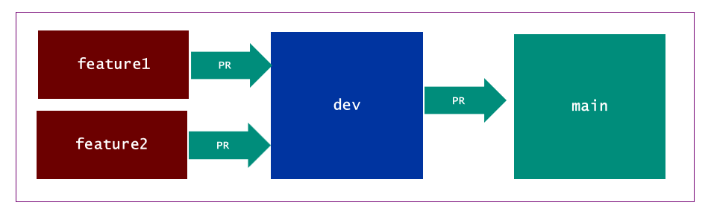
Here is what the high-level process looks like from the perspective of commits and merges

At completion of the PR, the changes in the feature branch are merged to dev and can be tested with all the other code that have been merged into that branch. Once the team is happy with the changes testing in dev has .
TO DO: talk about merge conflicts and techniques for resolving them
Additional Resources
- Learn about create pull request ub Azure DevOps
- Learn about working with branches in GitHub
- Learn how to resolve merge conflicts

Developing Automated Workflows
Pull requests are used to merge changes to a target repository. An essential aspect of CI/CD is automating when happens next after a pull request is approved and its changes have been merged into a target branch. What happens next is defined by the logic defined in a workflow that is automatically triggers upon pull request completion.
- GitHub Actions
- Azure DevOps Pipelines
What is typically done in one of these workflows.
Additional Resources
- Get tarted with Azure DevOps pipelines
- Get started with GitHub actions

Working with Environments
Talk about different environments with different environment settings.
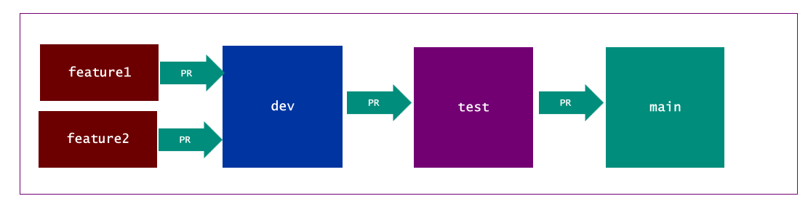
Automation pipelines run automated builds to run tests to analyze code
Additional Resources
- Learn about variable groups and secrets with Azure DevOps
- Learn about environments and secretes in GitHub repositories
Once the pull request is approved and the feature branch is merged, it triggers a workflow to automate pushing the changes from the dev branch up ino the dev workspace.
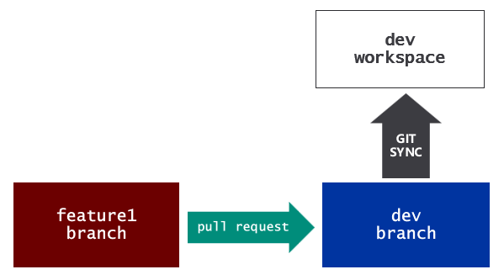

Managing GIT integration for projects with multiple workspaces
Infrastructure components in Fabric CI/CD include creating and managing Fabric items such capacities, workspaces and connections.
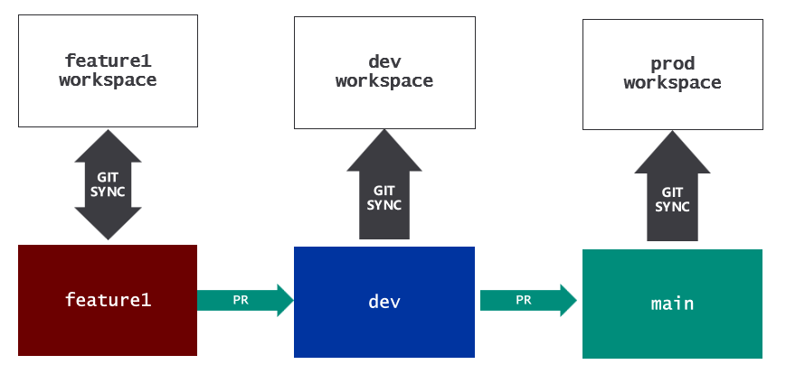

Managing Item Relations Across Workspaces

